**Indira Gandhi Delhi Technical University for Women**

**(Established by Govt. of Delhi vide Act 09 of 2012)**

**(Formerly Indira Gandhi Institute of Technology)**

**Kashmere Gate, Delhi - 110006**



**LABORATORY FILE**

**for**

**Web Technologies**

**MCA 207**

**Submitted by:**

**Submitted to:**

Ms. Ankita Singh Roopal Mittal

MCA, 3rd Sem

02004092019

**Date: 27-08-2020**

**LAB 4 WORK**

**Ques 7: Put validation checks on values entered by the user using JavaScript on:**

**(a) Student login form**

**HTML Code:**

<!DOCTYPE html>

<html>

<head>

<title>Login Form</title>

<script src="validation_login.js"></script>

<link rel="stylesheet" href="validation_login.css">

</head>

<body onload='document.login.email.focus()'>

<div>

<h2>Login Form</h2>

<form name="login" onsubmit="return validateForm()">

<label for="email">Email Id: </label>

<input type="text" id="email" name="email" required><br><br>

<label for="password">Password: </label>

<input type="password" id="password" name="password" onkeyup='check();' required><br><br>

<label for="cpassword">Confirm Password: </label>

<input type="password" id="cpassword" name="cpassword" onkeyup='check();' required><br><br>

<button type="submit" onclick="validateForm(document.login.email)"> Login</button>

<button type="reset">Clear</button>

</form>

<a href="reset%20password.html">Forget Password</a> <br> <br>

</div>

</body>

</html>

**CSS Code:**

body

{

background-color: black;

padding-left: 550px;

padding-top: 50px;

padding-right: 500px;

font-family: sans-serif;

}

div

{

border: solid;

padding: 50px;

background-color: #DAF7A6;

}

**JS Code:**

function validateForm(inputText)

{

var mailformat = /^\w+([\.-]?\w+)*@\w+([\.-]?\w+)*(\.\w{2,3})+$/;

if(inputText.value.match(mailformat))

{

document.login.email.focus();

return true;

}

else

{

alert("You have entered an invalid email address!");

document.login.email.focus();

return false;

}

}

var check = function() {

if (document.getElementById('password').value != document.getElementById('cpassword').value)

{

alert("Both the passwords are not same");

return false;

} else {

return true;

}

}

**OUTPUT Webpage:**

**Validation check on email_address.**

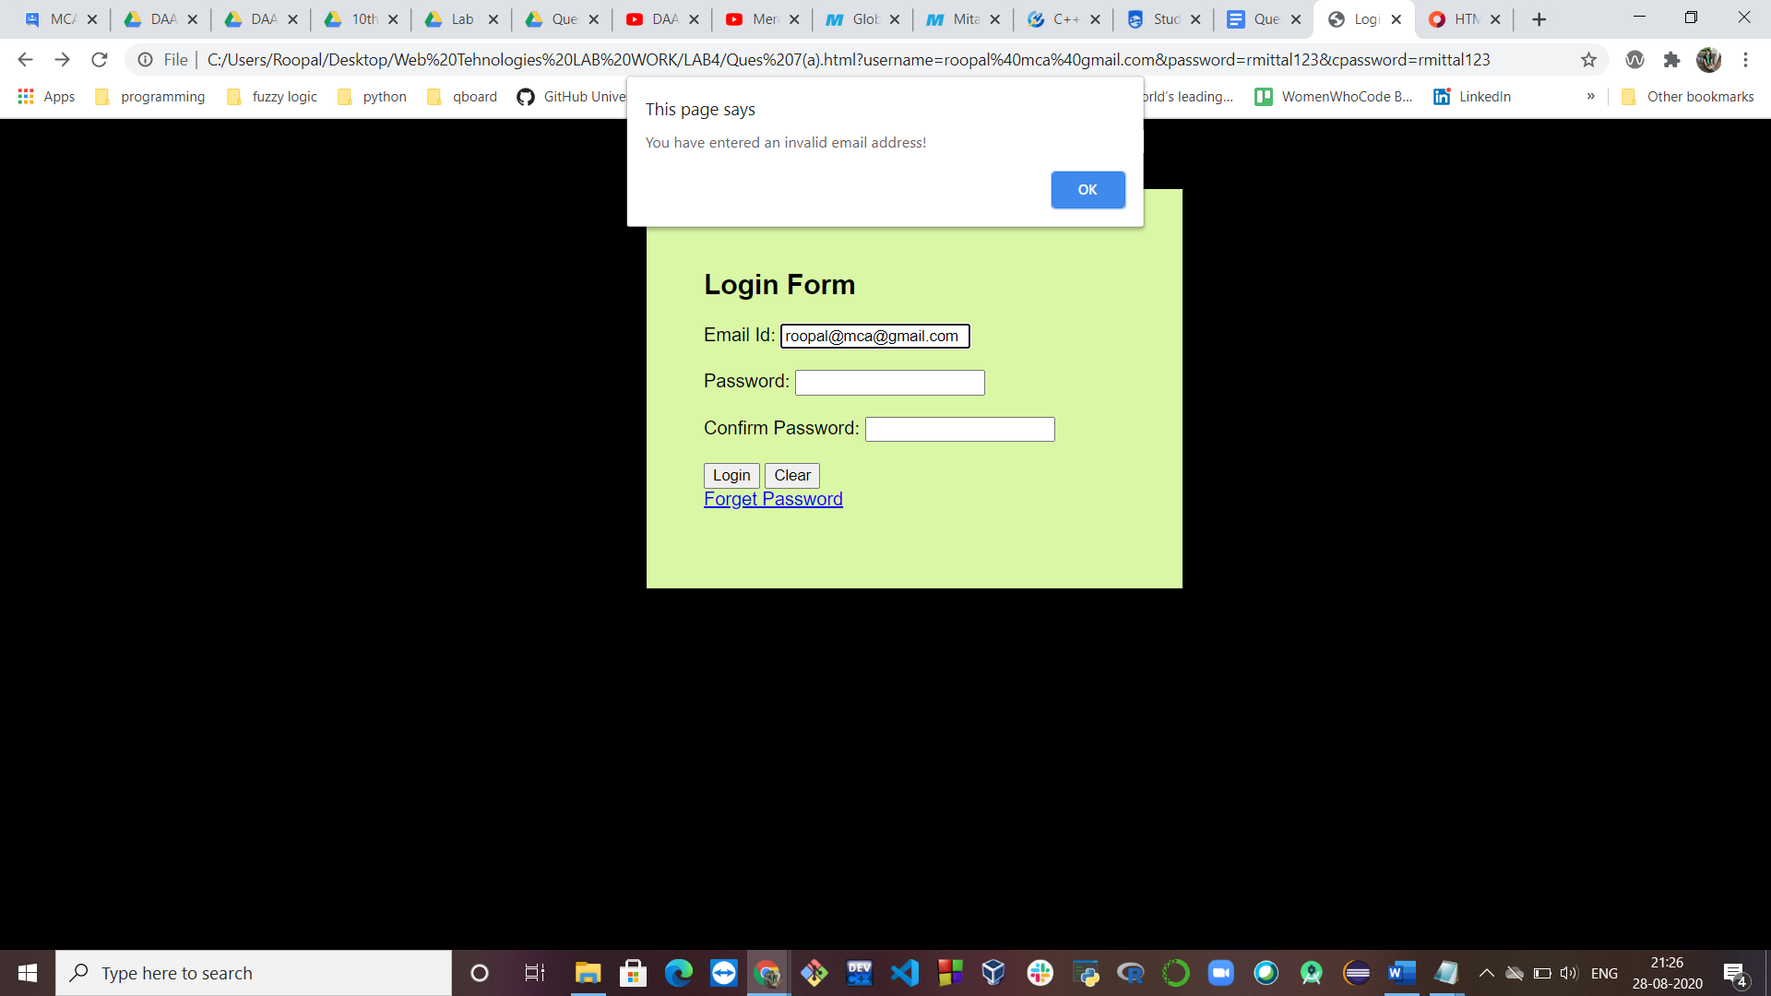

**Validation check on empty entry**

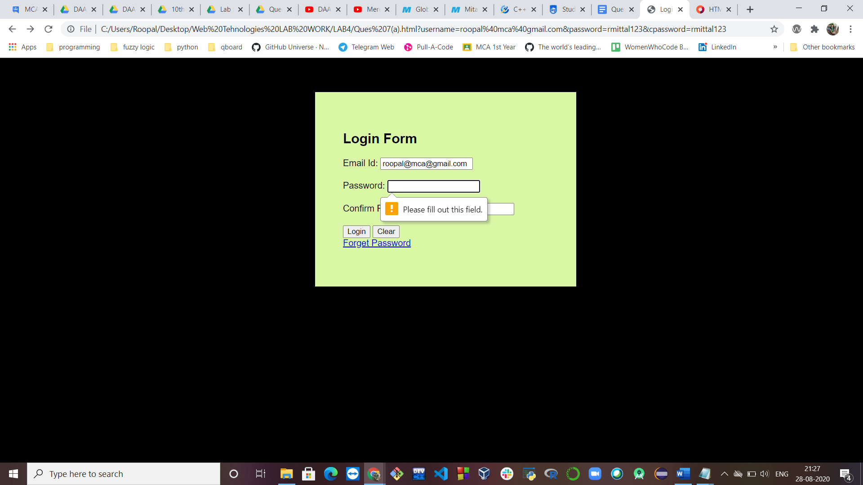

**Checking passwords are same or not**

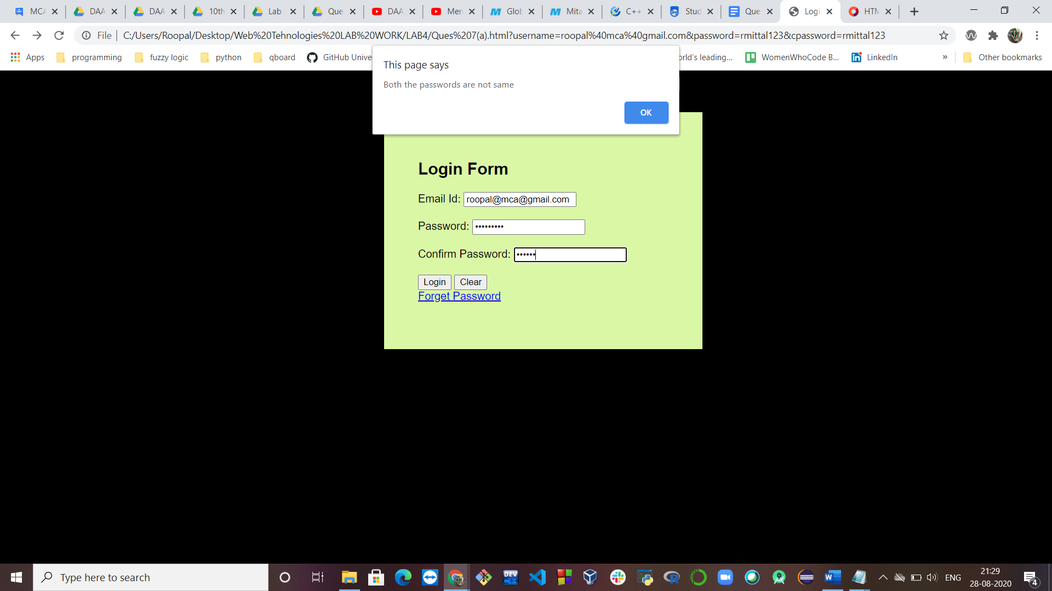

**(b) Registration form**

**HTML Code:**

<html>

<head>

<title>Register</title>

<script src="validation_register.js"></script>

<link rel="stylesheet" href="validation_register.css">

</head>

<body onload='document.register.fname.focus()'>

<div>

<h2>Registration Form</h2>

<h5>Want to proceed further? Register yourself!</h5>

<form name="register" onsubmit="return validateForm()">

<label for="fname">First Name: </label>

<input type="text" id="fname" name="fname" required><br><br>

<label for="lname">Last Name: </label>

<input type="text" id="lname" name="lname" required><br><br>

<label for="fname">Email Id: </label>&nbsp;&nbsp;

<input type="text" id="email" name="email" required><br><br>

Gender: &nbsp;

<input type="radio" id="gender" name="gender" value="gender">

<label for="male">Male</label>

<input type="radio" id="female" name="gender" value="female">

<label for="female">Female</label>

<input type="radio" id="other" name="gender" value="other">

<label for="other">Prefer not to say</label> <br> <br>

<label for="cars">Birthday:</label>&nbsp;&nbsp;

<select id="day" name="day">

<option value="1">1</option>

<option value="2">2</option>

<option value="3">3</option>

<option value="4">4</option>

<option value="5">5</option>

<option value="6">6</option>

<option value="7">7</option>

<option value="8">8</option>

<option value="9">9</option>

<option value="10">10</option>

<option value="11">11</option>

<option value="12">12</option>

<option value="13">13</option>

<option value="14">14</option>

<option value="15">15</option>

<option value="16">16</option>

<option value="17">17</option>

<option value="18">18</option>

<option value="19">19</option>

<option value="20">20</option>

<option value="21">21</option>

<option value="22">22</option>

<option value="23">23</option>

<option value="24">24</option>

<option value="25">25</option>

<option value="26">26</option>

<option value="27">27</option>

<option value="28">28</option>

<option value="29">29</option>

<option value="30">30</option>

<option value="31">31</option>

</select>

<select id="month" name="month">

<option value="Jan">January</option>

<option value="Feb">February</option>

<option value="Mar">March</option>

<option value="Apr">April</option>

<option value="May">May</option>

<option value="June">June</option>

<option value="July">July</option>

<option value="Aug">August</option>

<option value="Sept">September</option>

<option value="Oct">October</option>

<option value="Nov">November</option>

<option value="Dec">December</option>

</select> <br> <br>

Employment type:

<input type="checkbox" id="1" name="emp1" value="Student">

<label for="student"> Student</label>

<input type="checkbox" id="2" name="emp2" value="Job">

<label for="job"> Looking for a job</label>

<input type="checkbox" id="3" name="emp3" value="Intern">

<label for="intern"> Looking for internship</label> <br> <br>

<label for="textt">Tell us something about yourself:</label> <br>

<textarea id="textt" name="textt" rows="4" cols="50"></textarea><br><br>

<label for="lname">Password: </label>&nbsp; &nbsp;&nbsp; &nbsp;&nbsp; &nbsp;&nbsp; &nbsp;&nbsp;

<input type="password" id="password" name="password" onkeyup='check();' ><br><br>

<label for="lname">Confirm Password: </label>

<input type="password" id="cpassword" name="cpassword" onkeyup='check();' ><br><br>

<button type="submit" onclick="validateForm()">Register</button>

<button type="reset"> Reset </button>

</form>

</div>

</body>

</html>

**CSS Code:**

body

{

background-color: #D2B8E9;

padding-left: 400px;

padding-top: 50px;

padding-right: 400px;

font-family: sans-serif;

}

div

{

border: solid;

padding: 40px;

background-color: #A669DB;

;

}

**JS Code:**

function validateForm()

{

var firstname= document.getElementById("fname").value;

if(firstname=="")

{

alert("First name can't be empty");

return false;

}

else if(firstname < 5)

{

alert("Please use a name of more than 5 characters.");

return false;

}

else

{

return true;

}

var lastname= document.getElementById("lname").value;

if(lastname=="")

{

alert("Last name can't be empty");

return false;

}

else if(lastnamename > 20)

{

alert("Please use a short name of 10 characters.");

return false;

}

else

{

return true;

}

var mailformat = /^\w+([\.-]?\w+)*@\w+([\.-]?\w+)*(\.\w{2,3})+$/;

if(document.getElementById("email").value.match(mailformat))

{

document.register.email.focus();

return true;

}

else

{

alert("You have entered an invalid email address!");

document.register.email.focus();

return false;

}

}

var check = function() {

if (document.getElementById('password').value != document.getElementById('cpassword').value)

{

alert("Both the passwords are not same");

return false;

} else {

return true;

}

}

**OUTPUT Webpage:**

**Validation check to fill important fields**

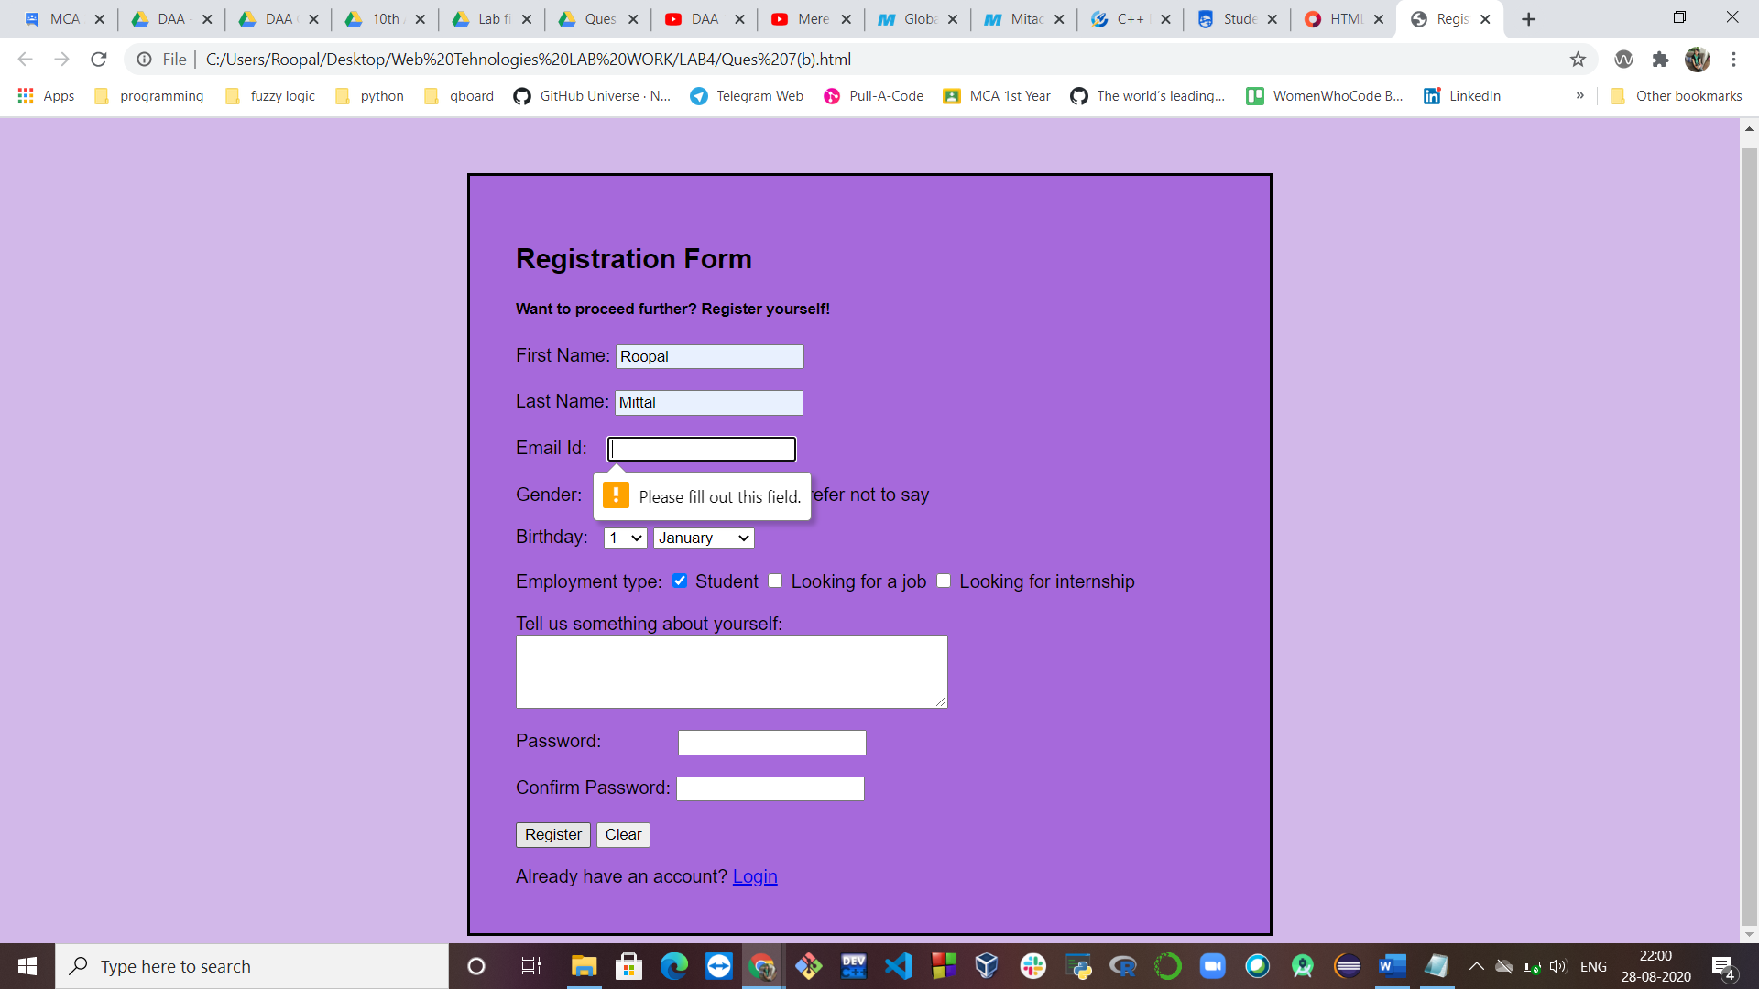

**Validation check on password match**

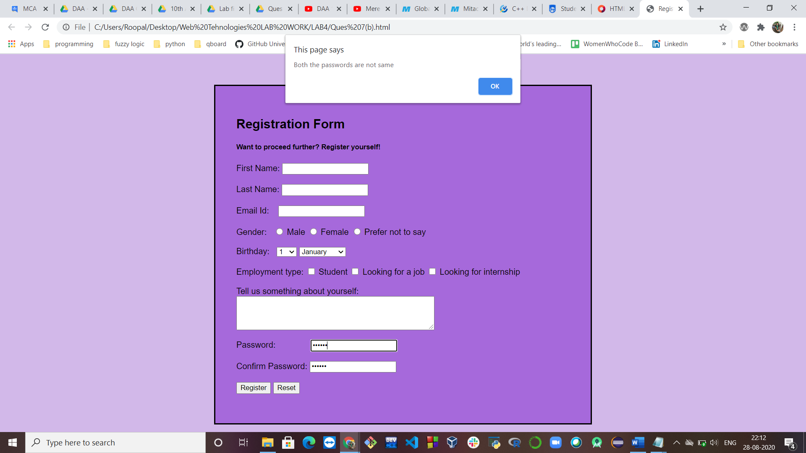

**Ques 8: Write a JavaScript that will allow to perform all arithmetic calculations(+,-*,/,%)**

**HTML Code:**

<!DOCTYPE html>

<html>

<head>

<title>Calculator</title>

<script type="text/javascript" src="calculator.js"></script>

</head>

<body bgColor="#FA8072">

<center>

<h1><font color="#180F99 "><b>Simple Calculator</b></font></h1>

<hr/><h2>

<table border="0">

<tr>

<td align="right" colspan="5">Enter 1st value : <input type="text" size="20" value="" id="textVal1">

</td>

</tr>

<tr>

<td align="right" colspan="5">Enter 2nd value : <input type="text" size="20" value="" id="textVal2">

</td>

</tr>

<tr>

<td align="right" colspan="5">Result : <input type="text" size="20" id="result" value=""></td>

</tr>

<tr>

<td align="right"><input type="submit" style="height: 30px; width: 50px" onClick="adding()" value="+"></td>

<td align="right"><input type="submit" style="height: 30px; width: 50px" onClick="subtraction()" value="-"></td>

<td align="right"><input type="submit" style="height: 30px; width: 50px" onClick="multiplication()" value="*"></td>

<td align="right"><input type="submit" style="height: 30px; width: 50px" onClick="division()" value="/"></td>

<td align="right"><input type="submit" style="height: 30px; width: 50px" onClick="remainder()" value="%"></td>

</tr>

</table>

</h2><hr/>

</center>

</body>

</html>

**JAVASCRIPT Code:**

function adding() {

var v1 = parseInt(document.getElementById("textVal1").value);

var v2 = parseInt(document.getElementById('textVal2').value);

document.getElementById("result").value = v1+v2;

}

function subtraction() {

var v1 = parseInt(document.getElementById("textVal1").value);

var v2 = parseInt(document.getElementById('textVal2').value);

document.getElementById("result").value = v1-v2;

}

function multiplication() {

var v1 = parseInt(document.getElementById("textVal1").value);

var v2 = parseInt(document.getElementById('textVal2').value);

document.getElementById("result").value = v1*v2;

}

function division() {

var v1 = parseInt(document.getElementById("textVal1").value);

var v2 = parseInt(document.getElementById('textVal2').value);

document.getElementById("result").value = v1/v2;

}

function remainder() {

var v1 = parseInt(document.getElementById("textVal1").value);

var v2 = parseInt(document.getElementById('textVal2').value);

document.getElementById("result").value = v1%v2;

}

**OUTPUT Webpage:**

**Addition of two numbers**

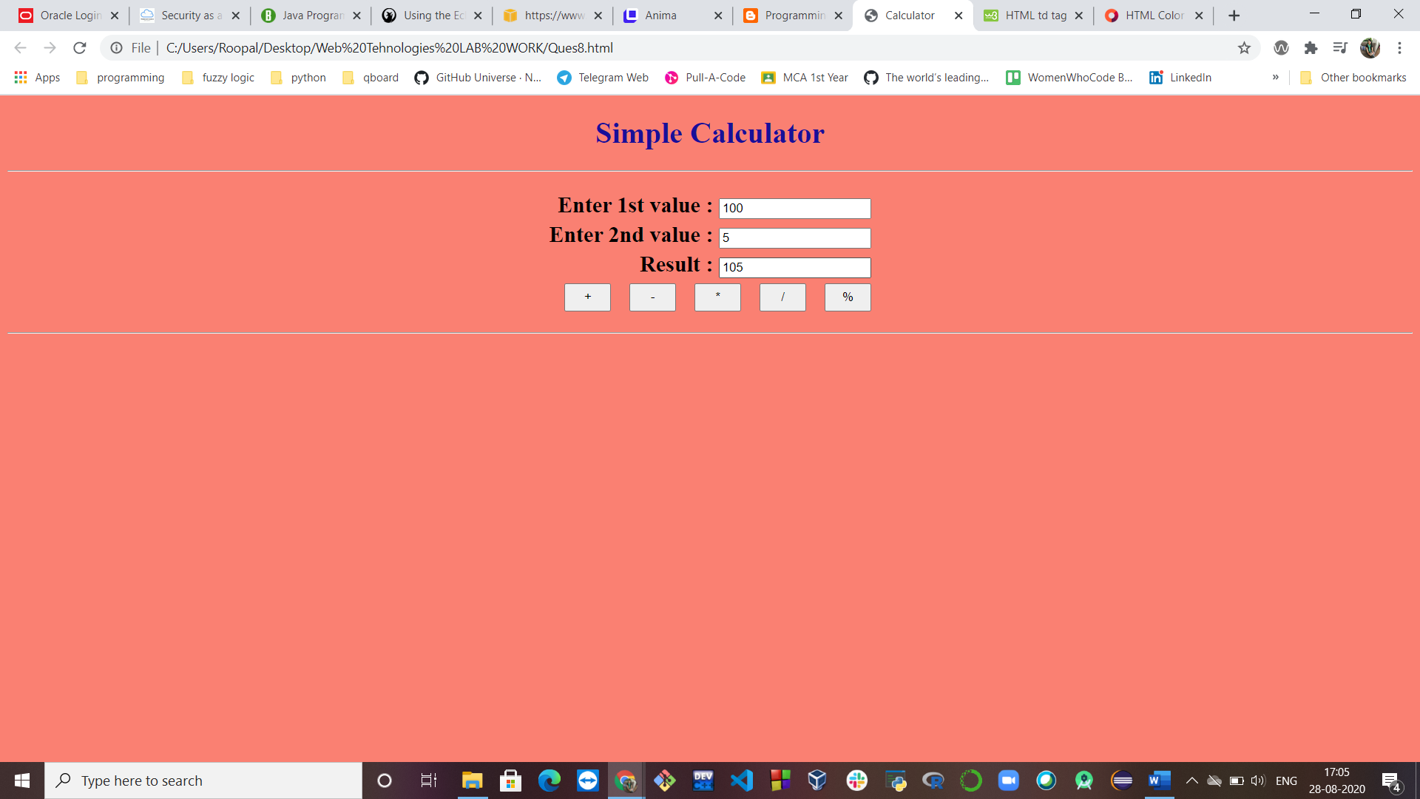

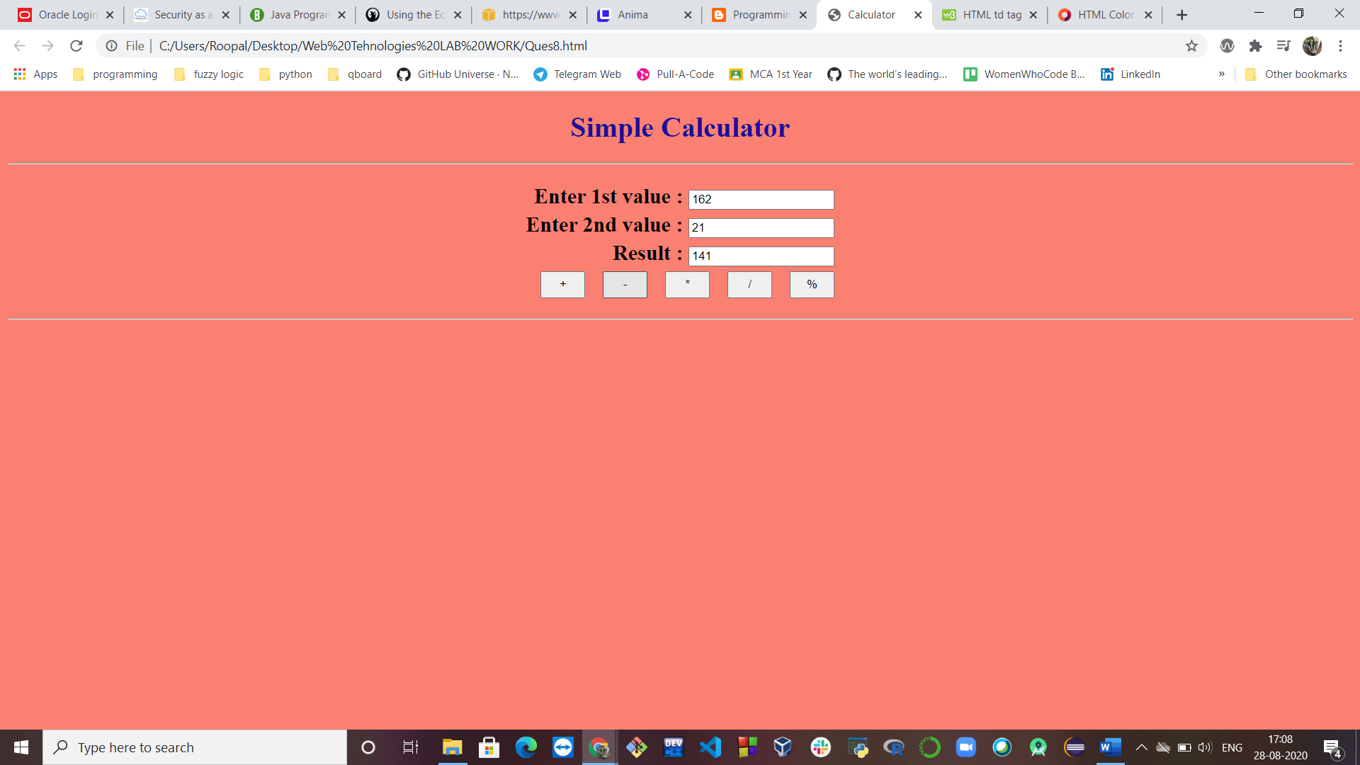

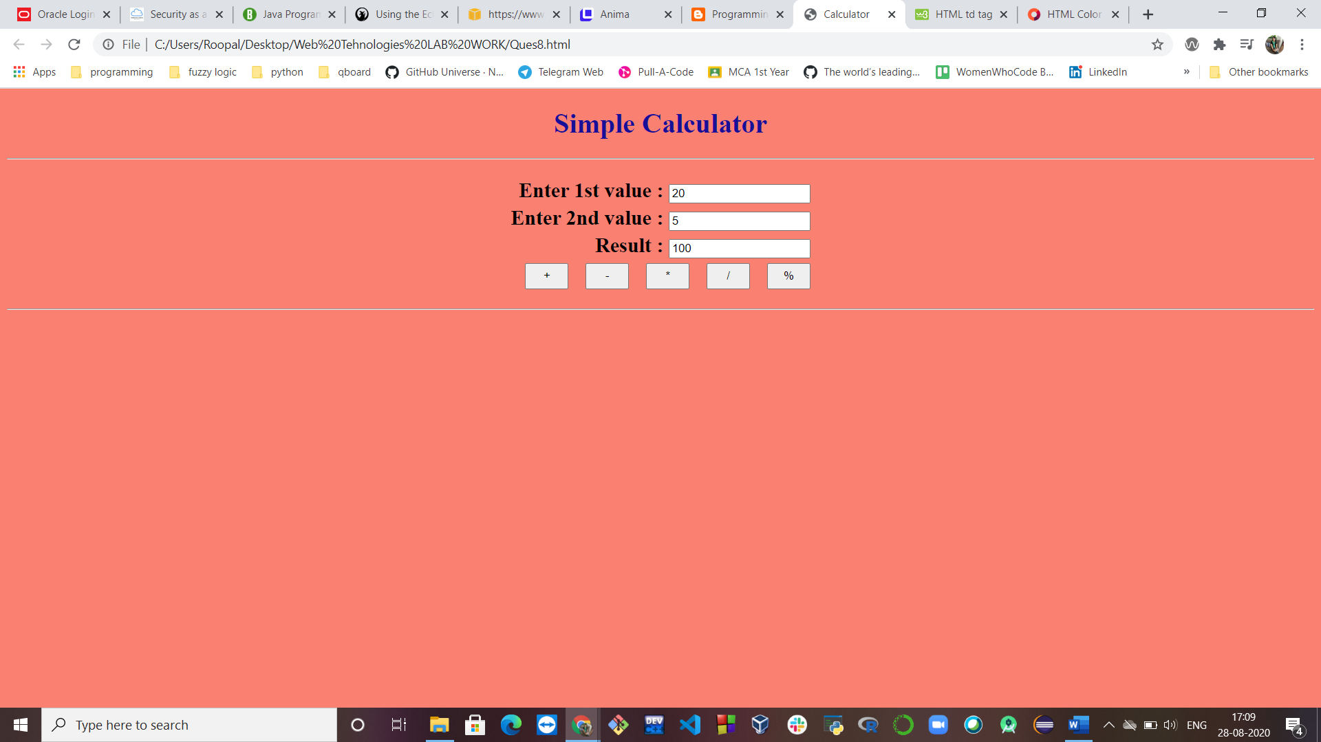

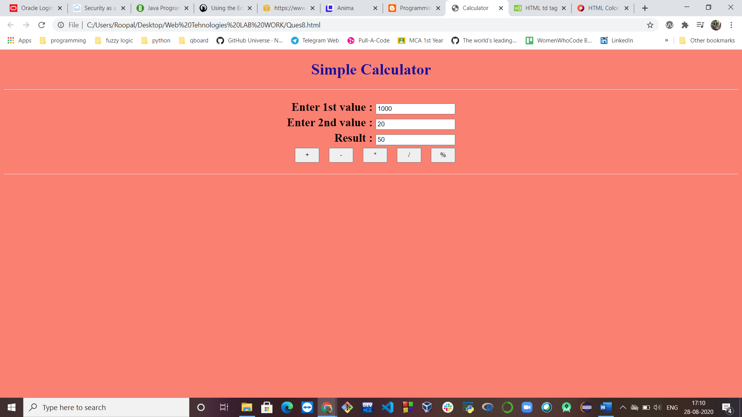

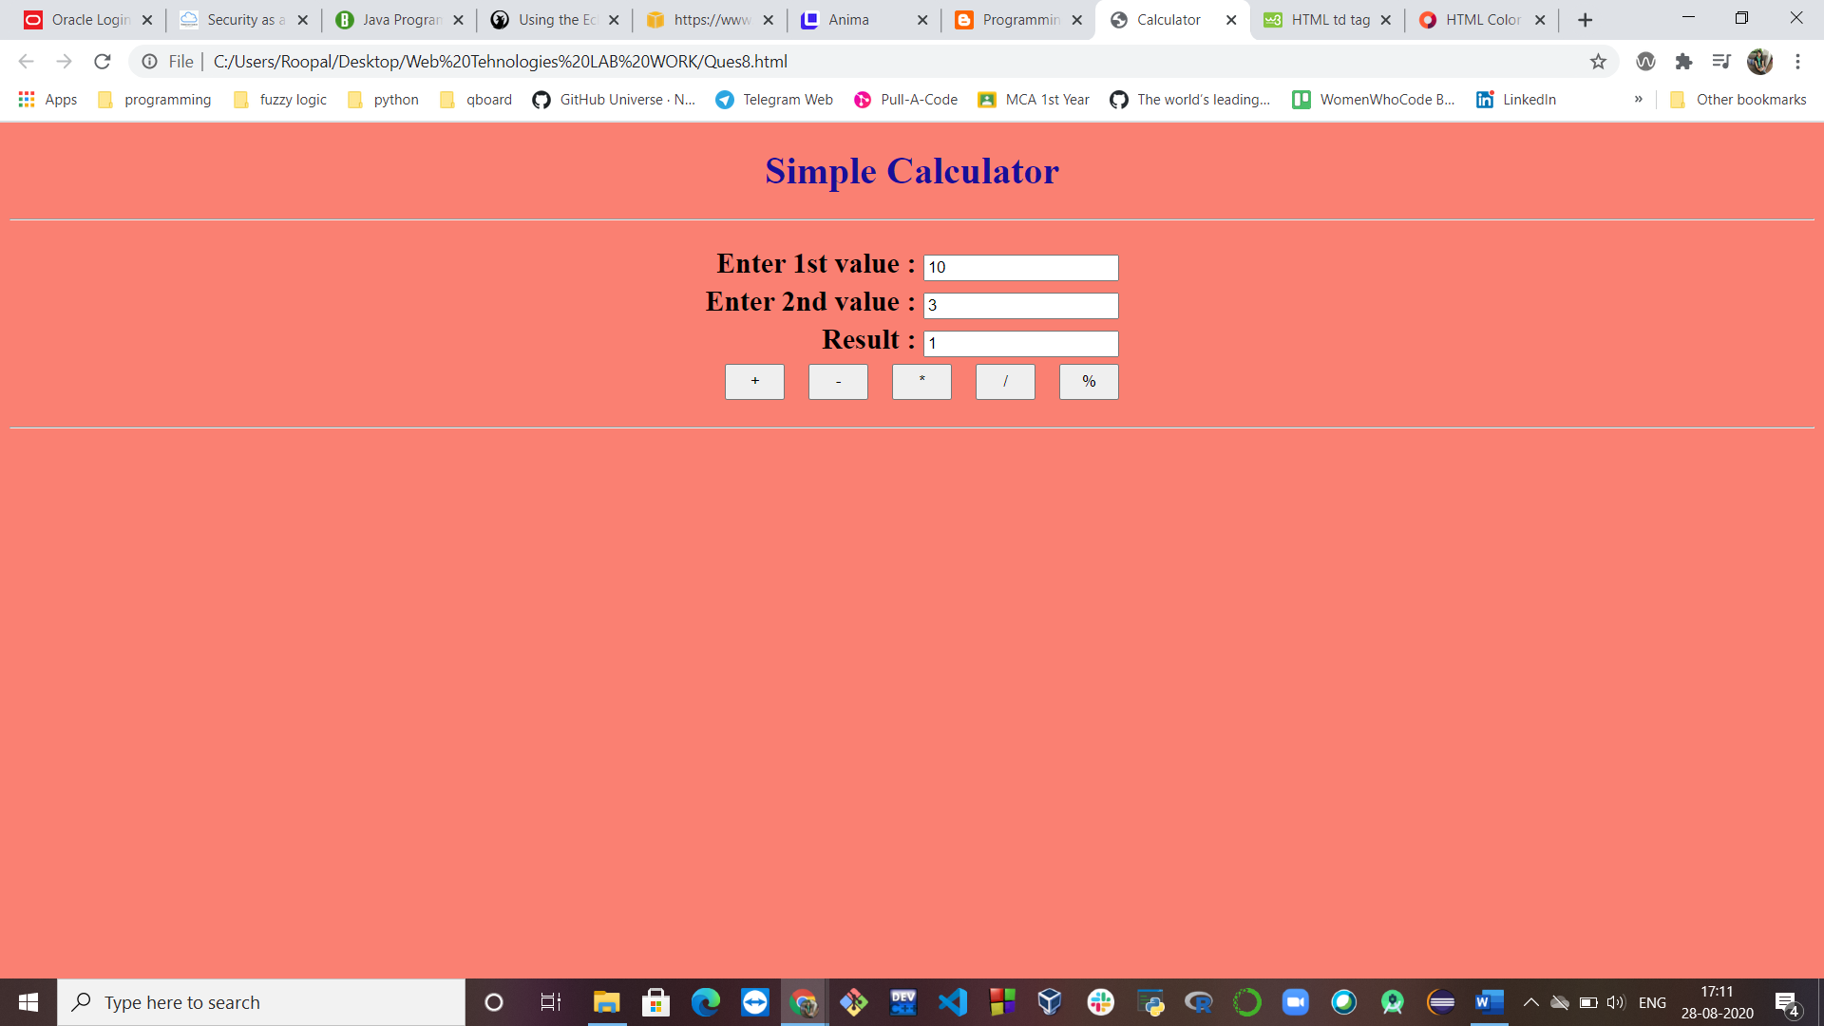

**Ques 8: Write a javascript to handle onclick, onchange, onfocus, onmouse, onload, onsubmit events.**

**HTML Code:**

<html>

<head>

<script type="text/javascript" src="Ques9.js">

</script>

</head>

<body onload="pageLoad()" bgcolor="black" text="white">

<center><h2>

<p>OnClick Method for displaying text</p>

<button onclick="displayMessage()">Click me</button>

<p id="demo"></p>

<p>OnChange Method to trigger the function to convert the text to UpperCase when the text field is left.</p>

Enter your name:

<input type="text" id="fname" onchange="myFunction2()">

<p>Click the text field to see a different colour and leave the text field to see a different colour.</p>

Enter your name:

<input type="text" id="myInput" onfocus="focusFunction()" onblur="blurFunction()">

</h2>

<h1 onmouseover="style.color='lightpink'" onmouseout="style.color='yellow'">Mouse over this text</h1>

<form onsubmit="confirmInput()">

<h2>Enter your name:</h2>

<input id="fname" type="text">

<input type="submit">

</form>

</center>

</body>

</html>

**JAVASCRIPT Code:**

function displayMessage()

{

document.getElementById("demo").innerHTML = "Hello, this is sample message.";

}

function myFunction2()

{

var x = document.getElementById("fname");

x.value = x.value.toUpperCase();

}

function focusFunction()

{

document.getElementById("myInput").style.background = "lightblue";

}

function blurFunction()

{

document.getElementById("myInput").style.background = "yellow";

}

function pageLoad()

{

alert("Page is loaded");

}

function confirmInput()

{

fname = document.forms[0].fname.value;

alert("Hello " + fname);

}

**OUTPUT Webpage:**

**onload**

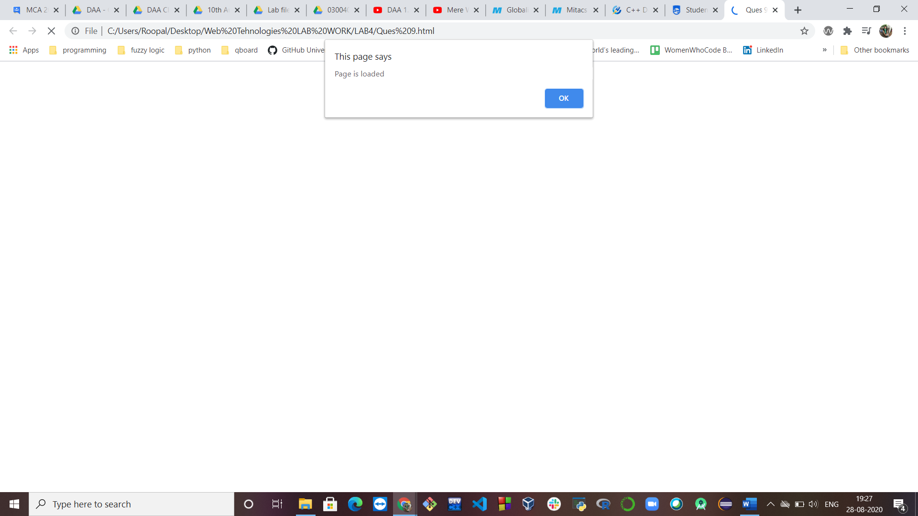

**Before onclick**

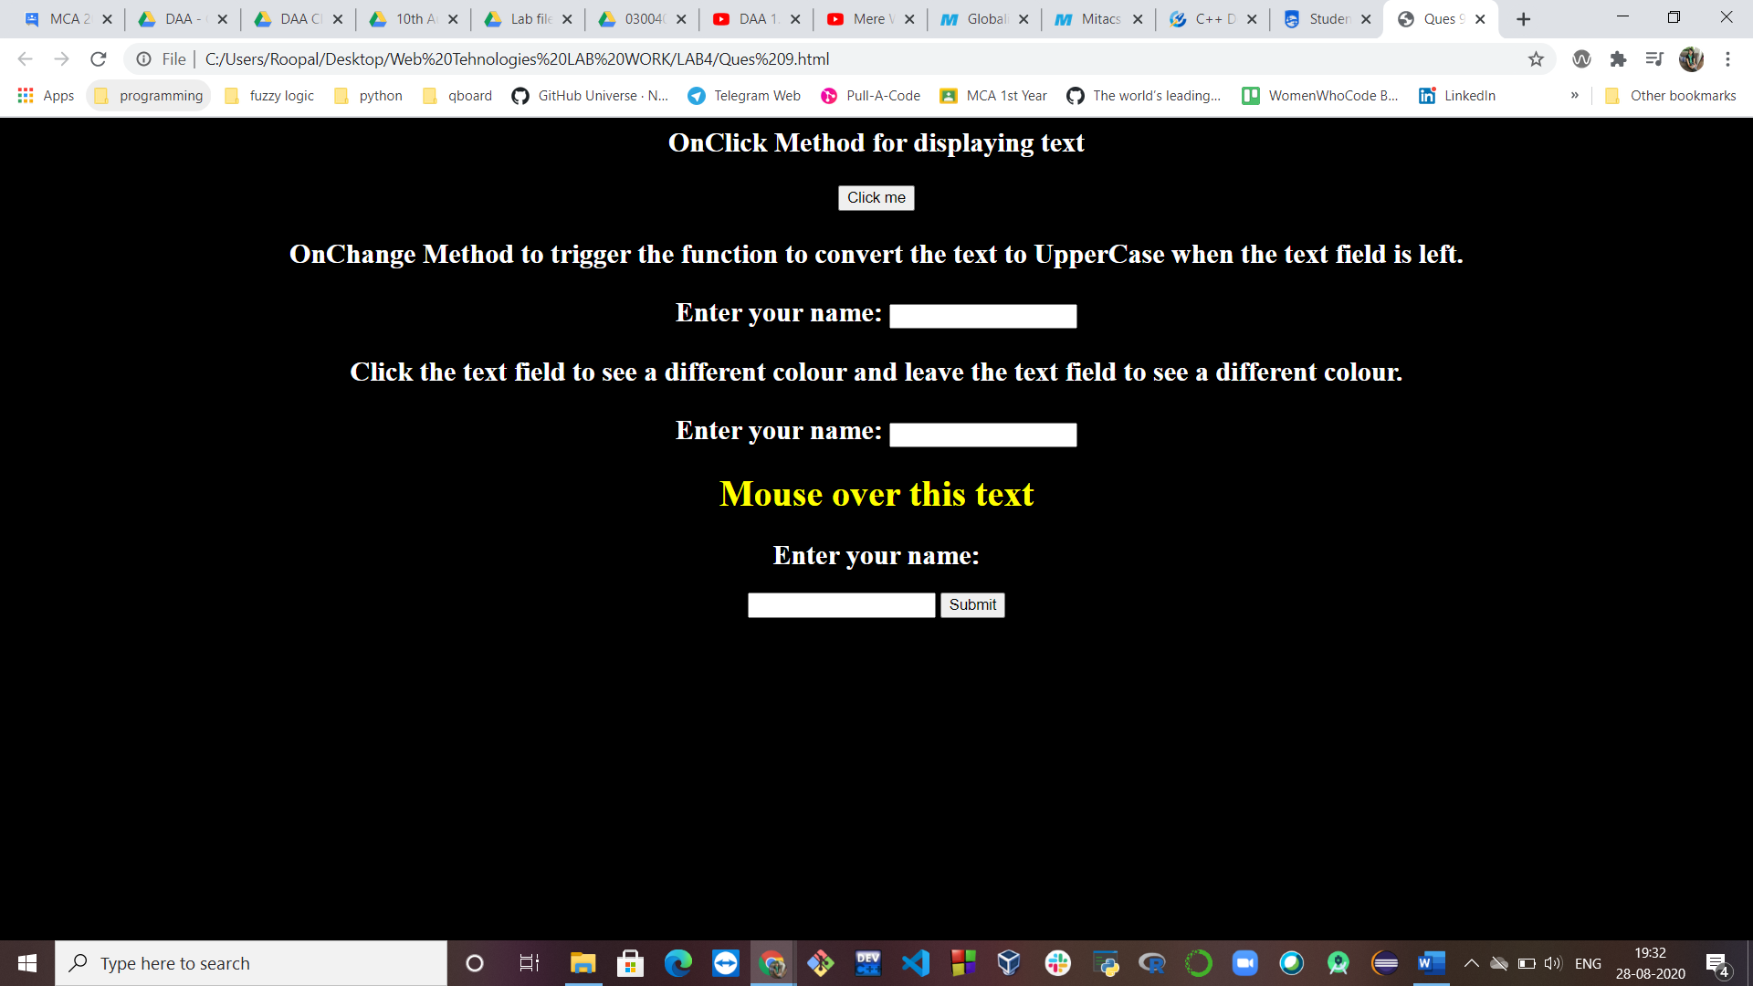

**After onclick**

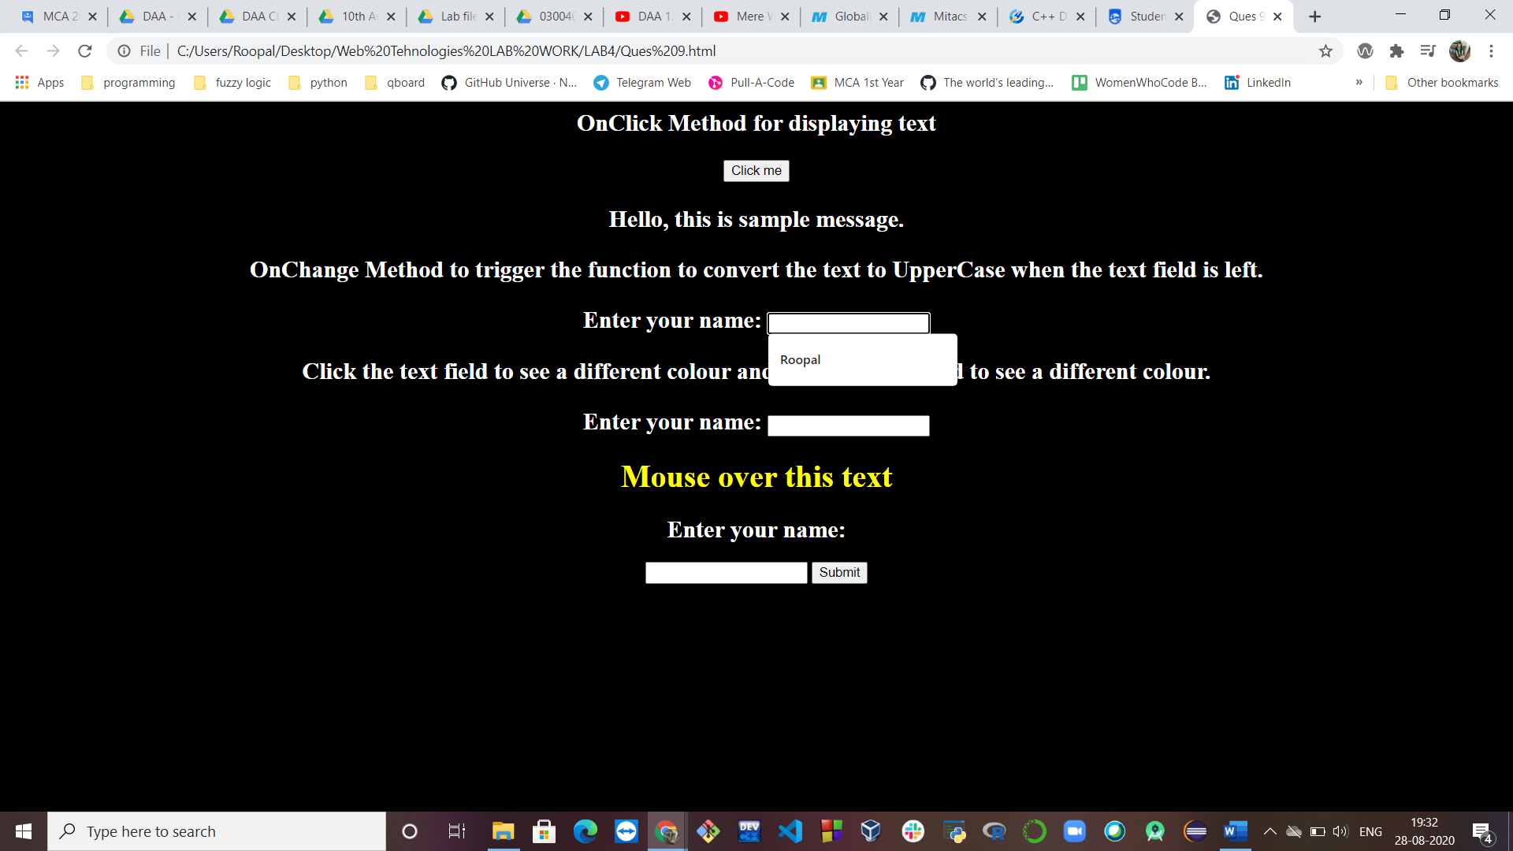

**onchange**

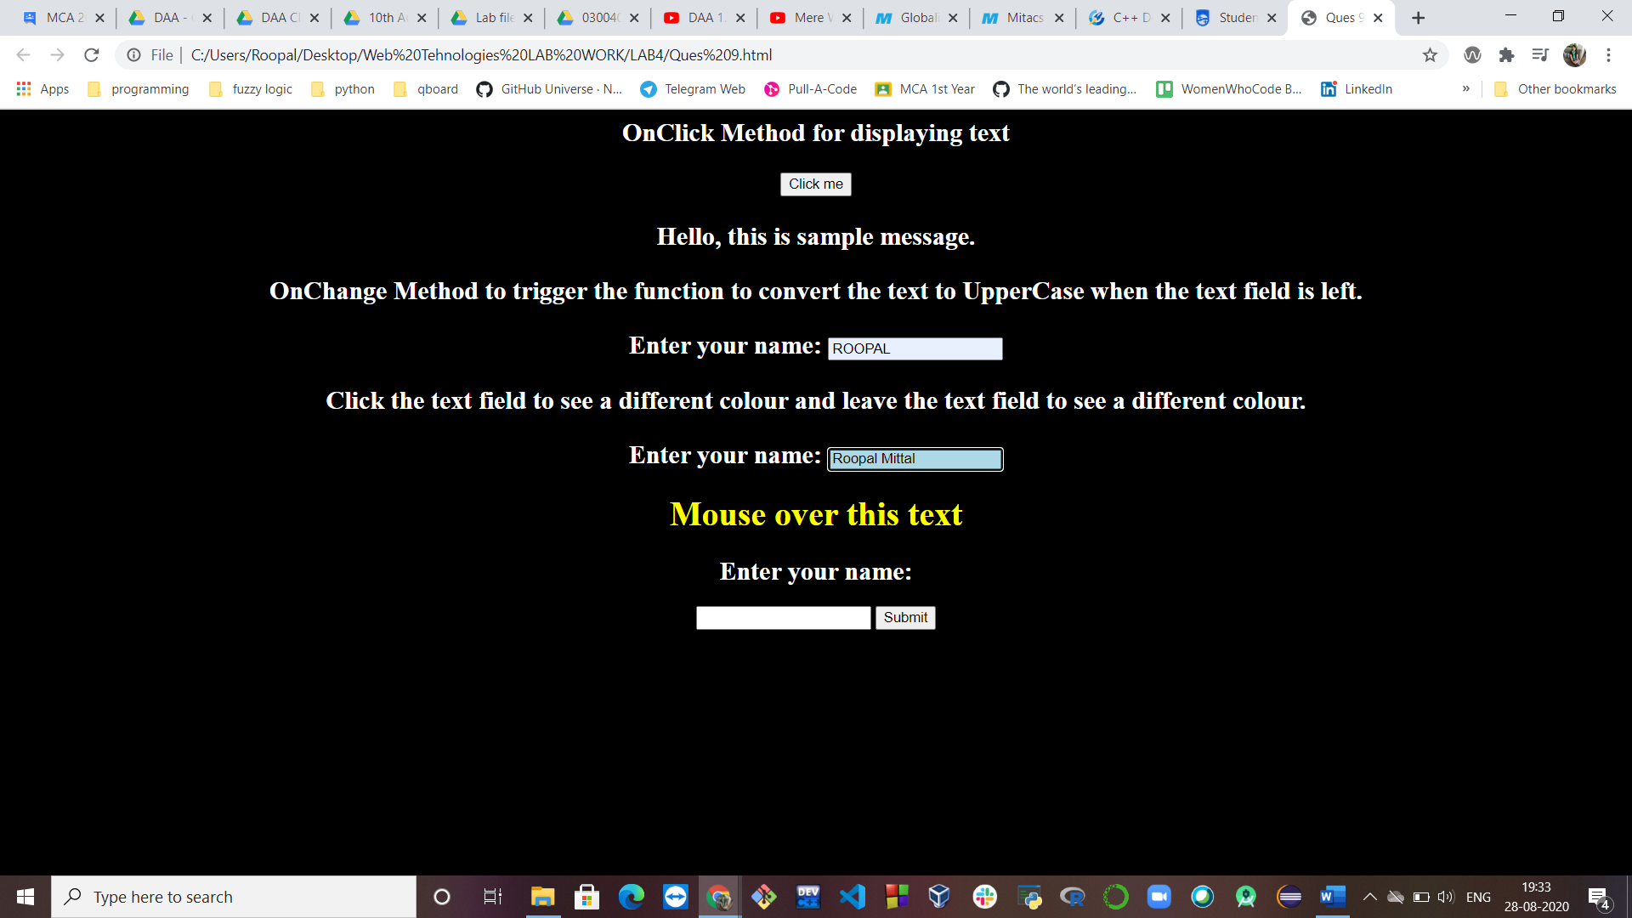

**Onfocus, onmouse**

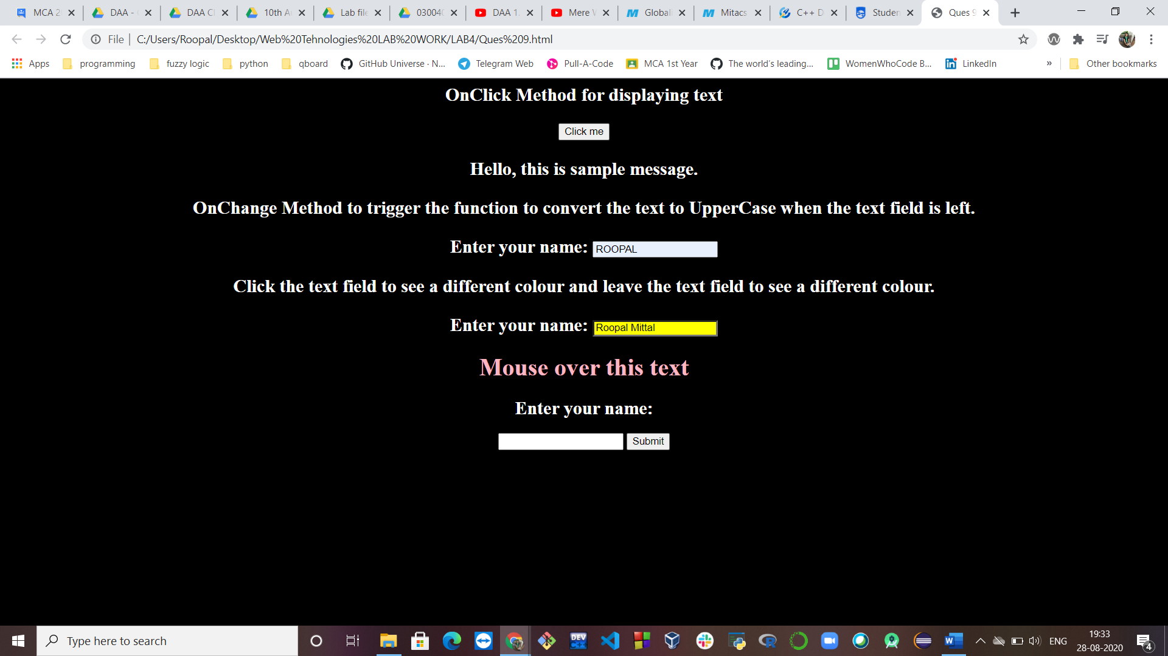

**onsubmit**

